**AIM:**

**To implement Quick Sort in C to sort an array in ascending order.**

**📌 ALGORITHM: *(Quick Sort)***

1. Pick a pivot element (commonly the last element).
2. Partition the array so that:
   * Elements smaller than the pivot are on the left,
   * Elements greater are on the right.
3. Recursively apply the above steps to the sub-arrays.

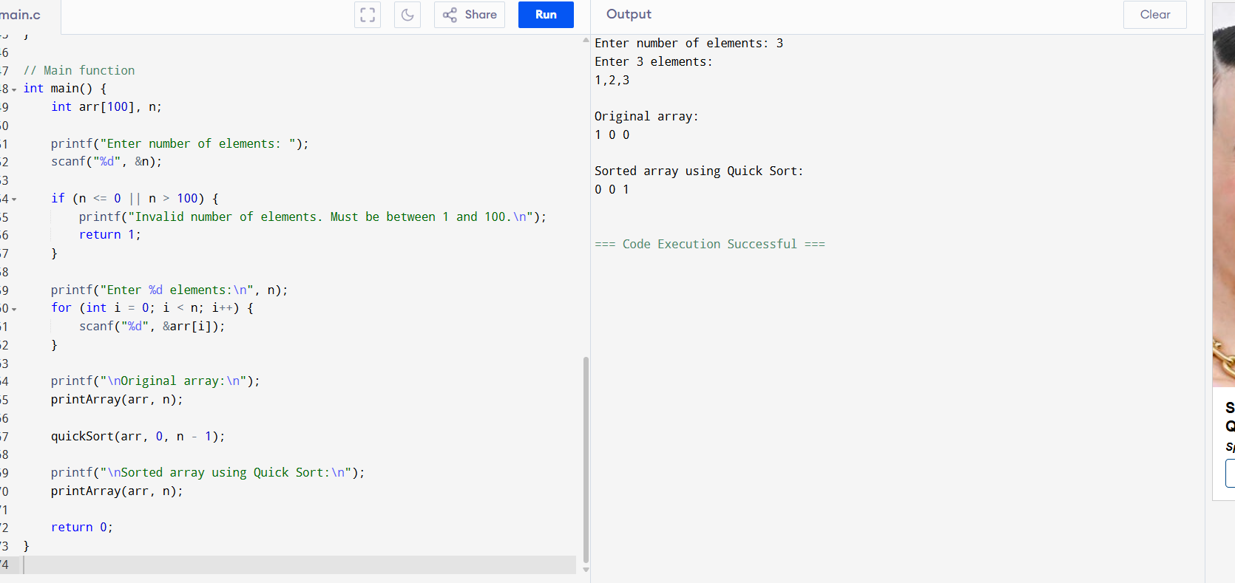

**SAMPLE OUTPUT:**

Enter number of elements: 5

Enter 5 elements:

29 10 14 37 13

Original array:

29 10 14 37 13

Sorted array using Quick Sort:

10 13 14 29 37